POST SNO INSTALLATION OCP_V SETUP

1. Openshift virtualization operator installation
2. Go to OperatorHub in web console & search openshift virtualization.

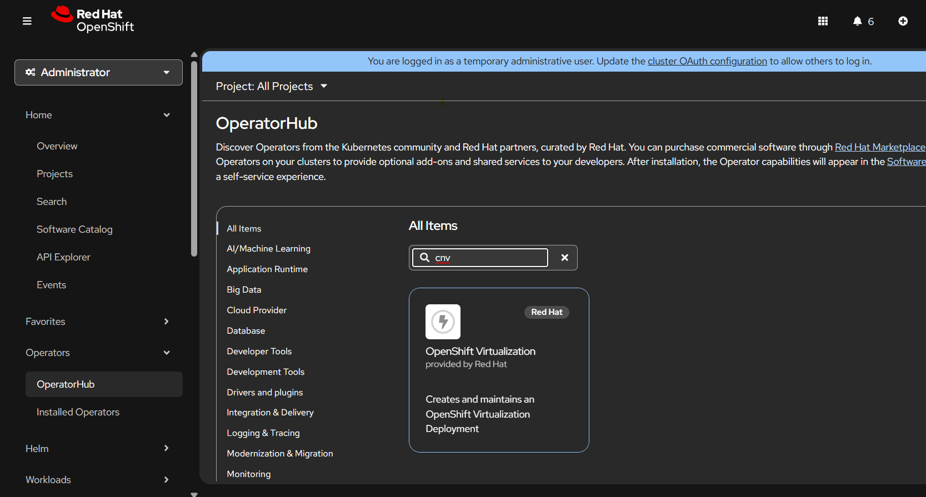

1. Install the openshift-virtualization operator and create hyperconverged instance.

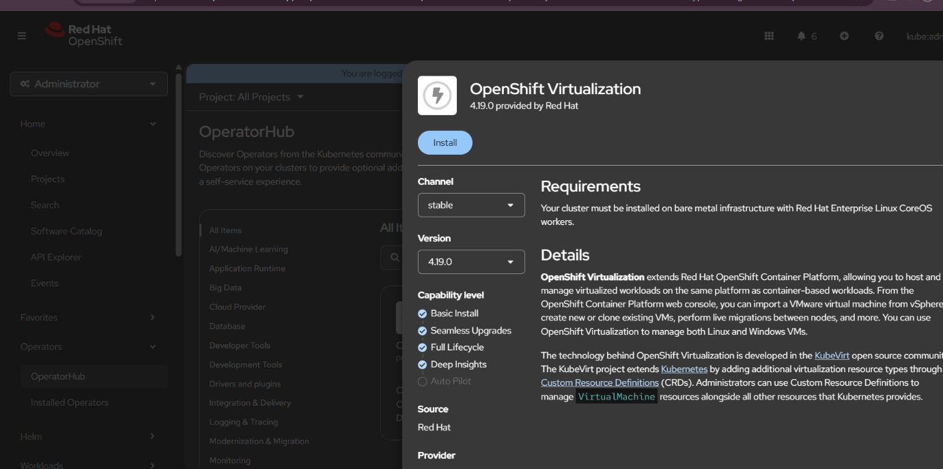

1. Hostpathprovisioner instance creation for use of local(server/node) storage for vm disks.
2. Go to HostPathProvisioner instance in extreme right.

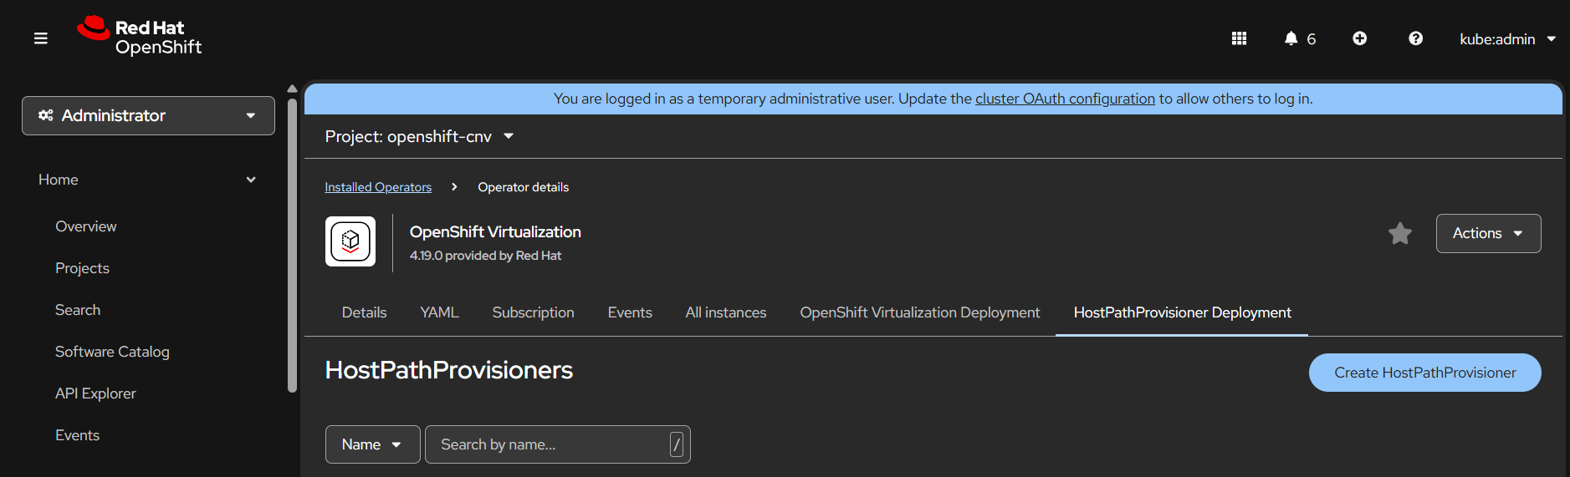

1. Create HostPathProvsioner instance using yaml format .

spec:

  imagePullPolicy: IfNotPresent

  storagePools:

    - name: local

      path: /var/hpvolumes

  workload:

    nodeSelector:

      kubernetes.io/os: linux

For path you can keep the default location or create a folder under /var and use it, make sure it has read write access

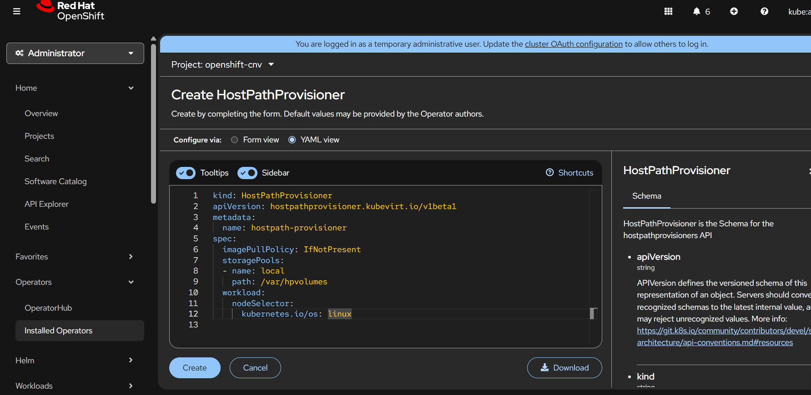

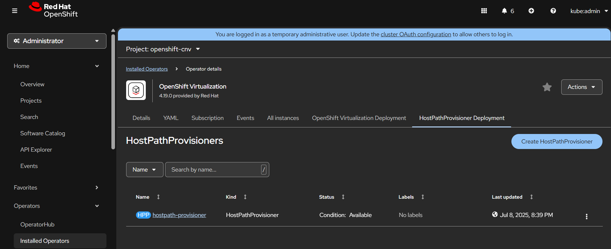

1. StorageClass instance creation with custom configuration
2. Create a storage class with Provisioner as hostpath-provisoner.

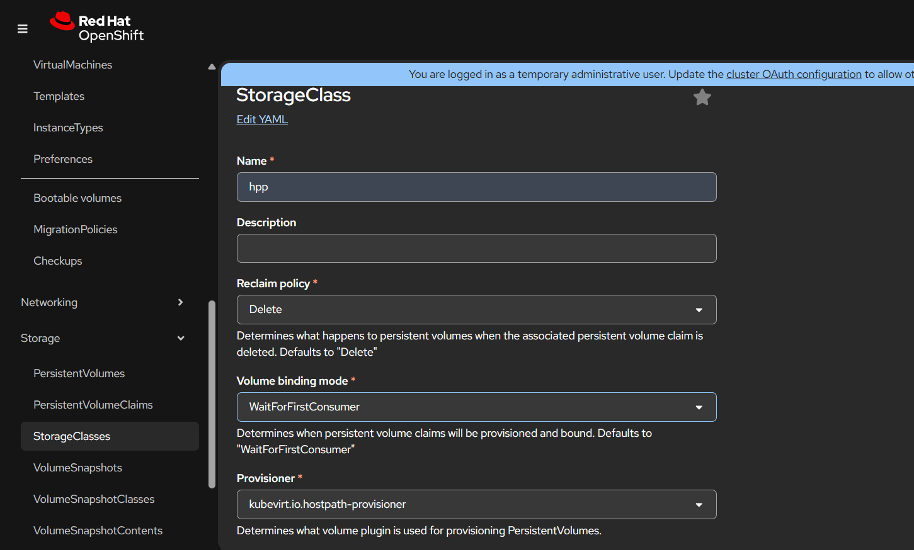

1. Select additional parameter as stroagePool=local

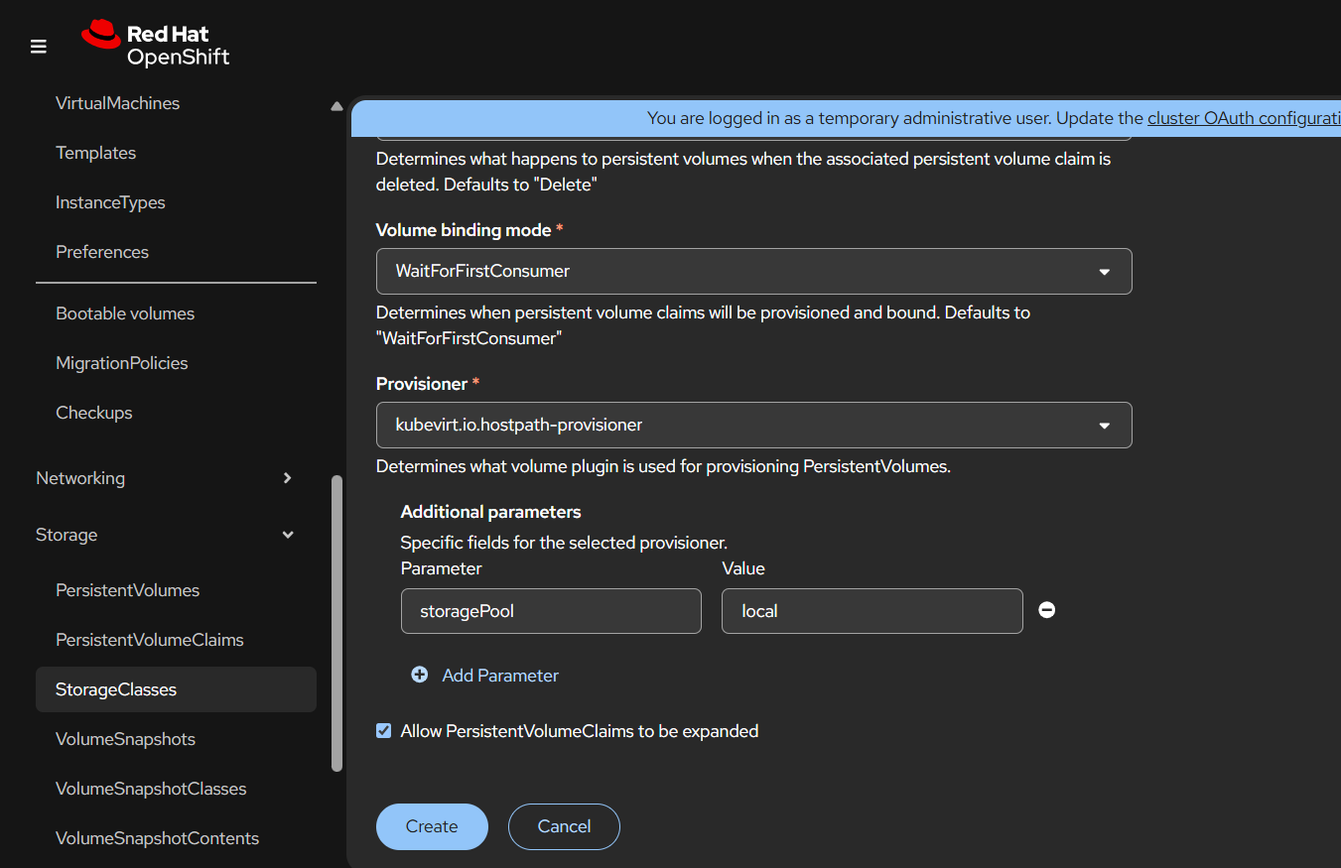

1. Annotate the storage class as default.

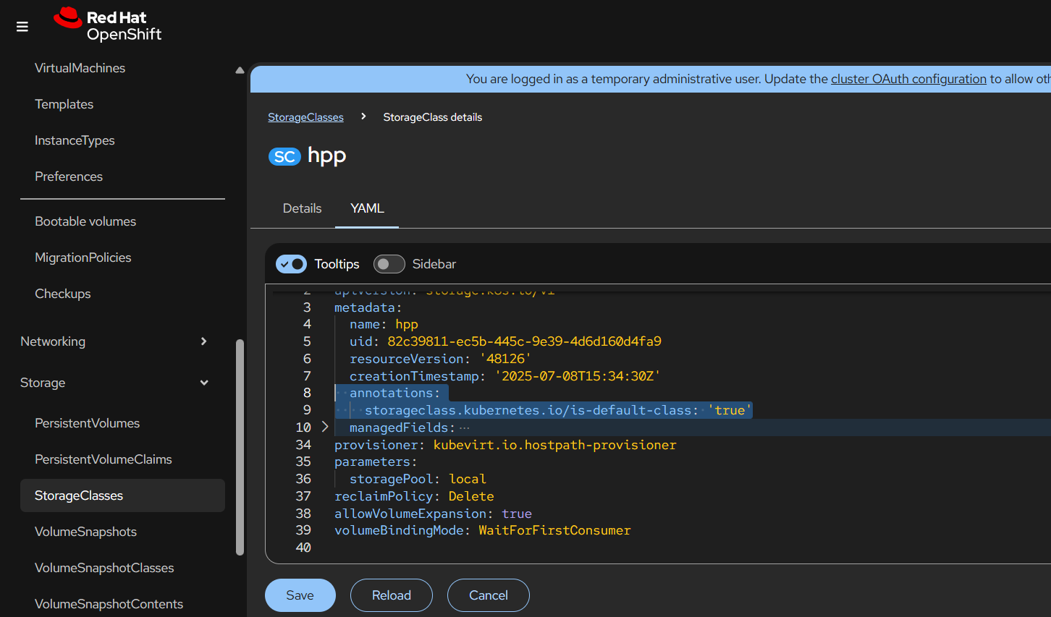

1. Internal image registry operator config changes.
2. Configure the internal image registry

$ oc edit configs.imageregistry.operator.openshift.io

  storage:

    managementState: Managed

    pvc:

      claim:

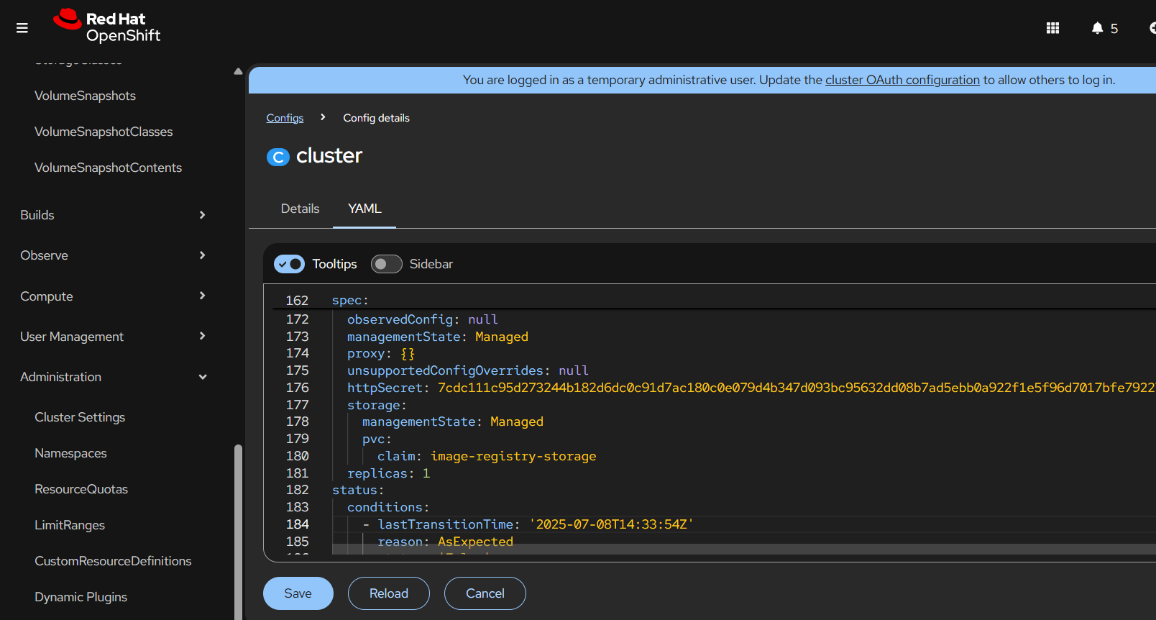

1. Check $ oc get pods -n openshift-image-registry

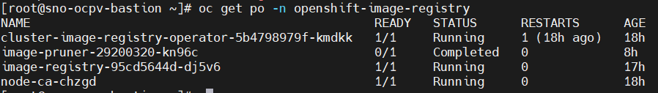

1. Check PVC whether pvc is in bound state.

